1. Highest marks obtained by: - Rahul
2. Highest marks obtained in physics:- 92(Akshaya,Aditya,Rahul,Abirami,)
3. Highest marks obtained in mathematics:-97(Rahul,Deepika)
4. Highest marks obtained in chemistry:-97(Abirami)

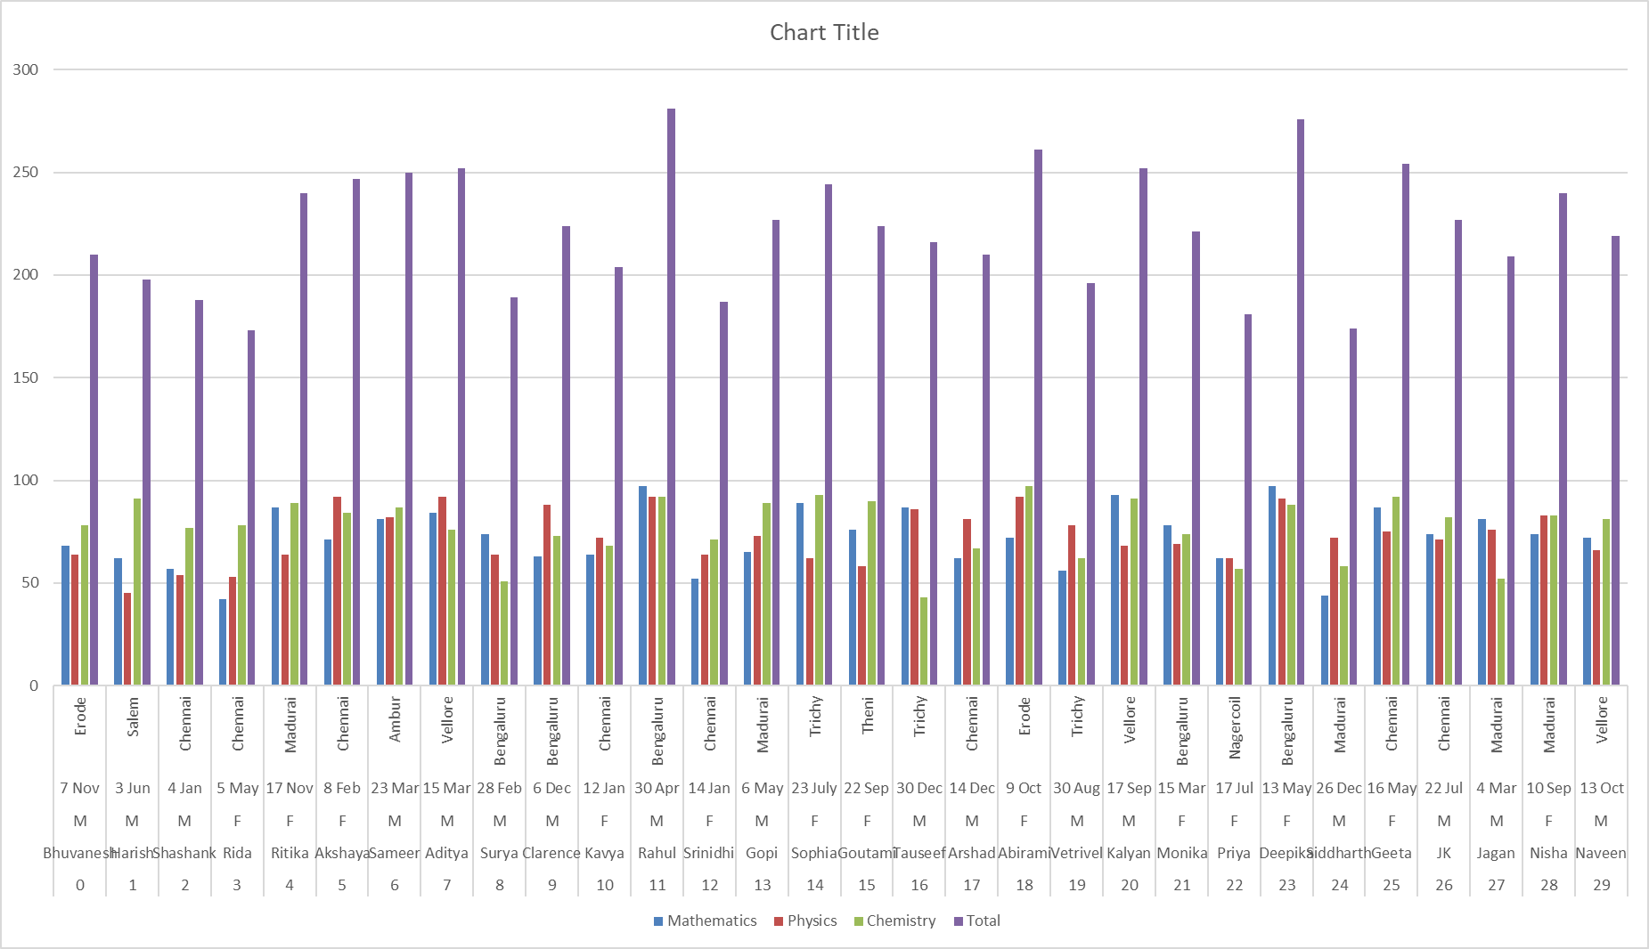

1. Students are from :-

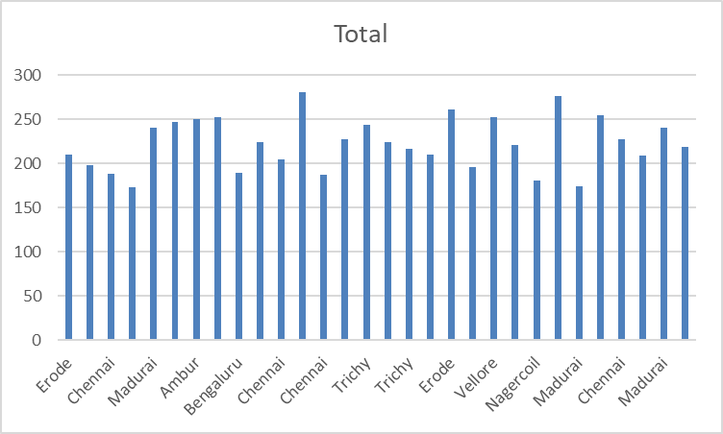

1. Maximum

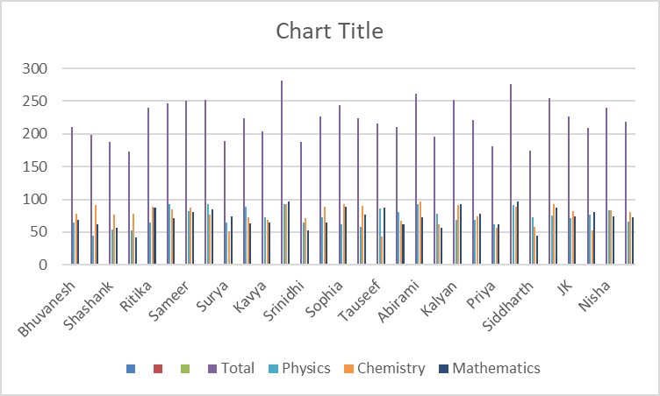

1. Mathematics average score is:- 72/100
2. Chemistry average score is:-73/100
3. Physics average score is:-73/100